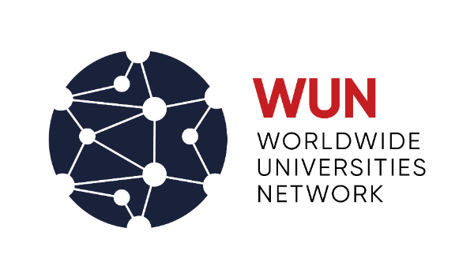

WUN Research Development Fund 2023 – Draft Proposal Form for Bristol PIs

Directions |  | Please return the completed form to: Jo.Brooks@bristol.ac.uk by Friday 22 September 2023.  More information is available on the UoB WUN webpage and on the WUN website.
Criteria |  | Proposals will be assessed against the following criteria:  - Objectives. Proposals should aim to build a multidisciplinary team of researchers to develop transformative solutions-focused research.  - Relevance to WUN themes. Proposals must address Sustainable Development. A clear articulation of how the proposal aligns with one or more of the following areas is required:  1. Social justice and human rights; inequality. 2. Sustainable world: cities and urbanization; energy transitions; water; food security. 3. Mental health; child and maternal health; ageing. 4. Responsible and ethical applications of Artificial Intelligence. Please view the RDF 2023 Guidelines for full details.  - Teamwork. Proposals should be led by academics with a track record of research excellence and involve a team of researchers across a range of relevant disciplines and regions.  - Partnership. Proposals should involve at least 3 WUN member universities across at least two regions (WUN regions are defined as North America, Latin America, Europe, Africa, Asia and Oceania). Proposals can also include non-WUN universities, WUN Knowledge Partners and other external partners (corporate, governmental, NGOs, think tanks, policymakers, international agencies).  - WUN Advantage. Consideration for how the set of individuals involved, and the environment and resources available to them, confers a distinctive advantage in tackling the research problem.  - Outcomes. Clear, realistic and well-considered outcomes such as securing external funding for continued research co-operation, academic publications and policy impact are expected.  - Sustainability. Proposals should aim to build long-term international collaborations and must include a clear and realistic plan for attracting external funding.
Title of Proposal |  | Click here to enter text.
Principal Investigator at the University of Bristol |  | Title | Click here to enter text.
 |  | First Name | Click here to enter text.
 |  | Last Name | Click here to enter text.
 |  | Position | Click here to enter text.
 |  | Department/School | Click here to enter text.
 |  | Contact phone | Click here to enter text.
 |  | Contact email | Click here to enter text.
Partner Institutions  Name of partner university and lead collaborator at that university. |  | WUN partner/s | Name of WUN partner  Click here to enter text. | Name of Collaborator  Click here to enter text.
 |  | Non-WUN universities | Name of university  Click here to enter text. | Name of Collaborator  Click here to enter text.
 |  | Other partners  Corporate, government partners, NGOs, think tanks, policymakers, etc. | Name of partner  Click here to enter text. | Name of Collaborator  Click here to enter text.
Draft Proposal to WUN RDF Scheme 2023
Enter a summary of your proposal written for a non-specialist audience (1 to 2 pages)
What do you want to do? Why do you want to do it? How will you do it? What is the expected outcome?

Relevance to RDF 2023 Theme: Sustainable Development (please see RDF 2023 Guidelines)
Click here to enter text.
Project Summary
Click here to enter text.

Relevance to WUN theme(s)
Click here to enter text.

Teamwork
Click here to enter text.

Partnership
Click here to enter text.

WUN Advantage
Click here to enter text.

Outcomes
Click here to enter text.

Sustainability – how the project will be sustained
Click here to enter text.

Head of School approval

Name
School
Signature
Date
Optional comments | Is there anything you would like to add in support of the project’s potential impact and sustainable design? (Please note that these are two of WUN's six selection criteria – see guidelines for more information)

